**COMP7940**

**Cloud Computing**

***Group Project***

|  |  |
| --- | --- |
| ***Student name*** | ***Student id*** |
| ***GU, Yuankang*** | ***21414122*** |
| ***Han, Yaoyang*** |  |

**Bot name: Cook**

**Username: Cookcooking2022_bot**

**Github ID： Harrybot2022**

**April 21, 2022**

Our bot is called Cook with username Cookcooking2022_bot.

**Summary**

This bot is designed to help users quickly find cooking-related websites and acquire relevant knowledge, such as recipes, cooking tips. In addition, it also provides a channel for users to YouTube or Twitter to share their cooking video

It has two functions and one user tip.

For tip, it can provide guidance to users, let them know that they can use the command find and share to enjoy the bot.

Users just need to type /help, and then they can see the details.

It shows how to use the command find and share by a tip. If user click the text ‘/find’ in blue, the bot will show the usage. If user click the text ‘/share’ in blue, the bot will show the usage as well.

Here is the demo.

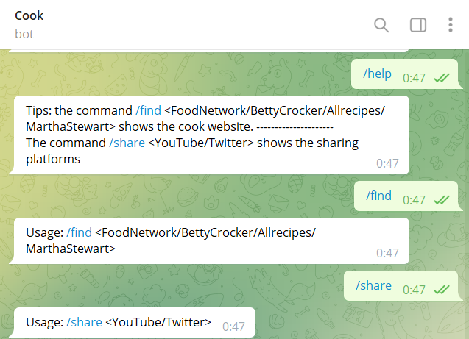

The first function is providing some cooking-related websites and acquire relevant knowledge, such as recipes, cooking tips. It helps users know what to prepare before cooking and how to cook.

Users need to type /find with the website name like FoodNetwork, BettyCrocker, Allrecipes, MarthaStewart which can provide assistance to users. Now, we just provide these four links, if users type another one, the bot will show usage.

Here is the demo.

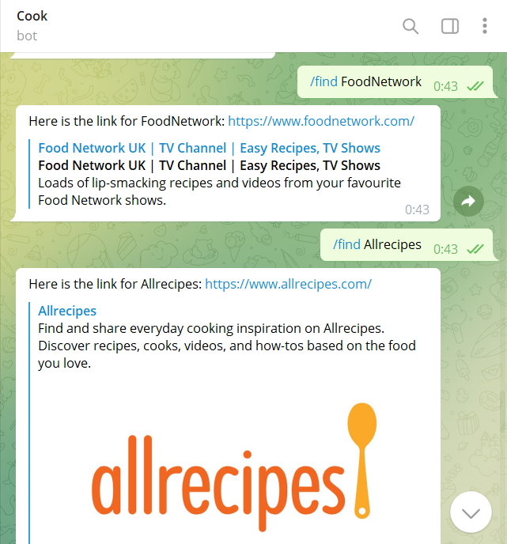

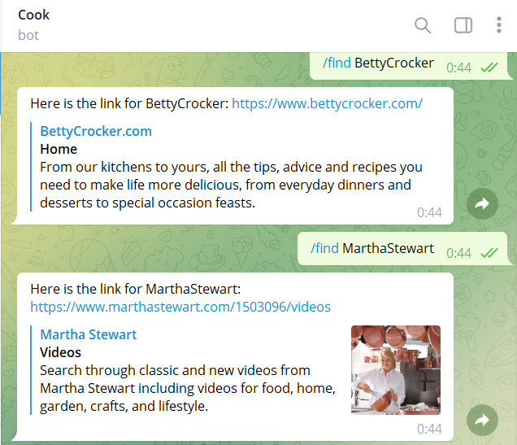

The second function provides a channel for users to YouTube or Twitter to share their cooking video. They can share their experience and happiness with people all of the world.

User need to type /share with the name YouTube and Twitter which are the famous social media in the world.

Here is the demo.

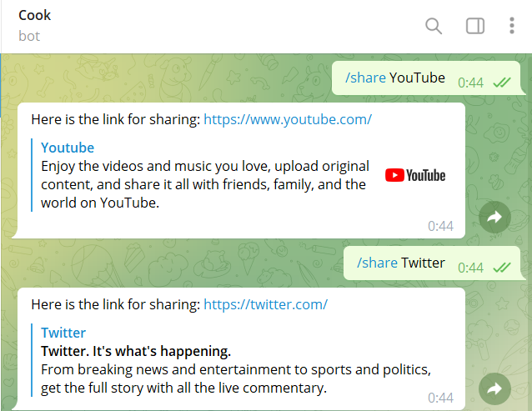

**Job division**

**GU Yuankang 21414122**

**Build the telegram bot, design the function with code for the bot.**

**Connect the app with a database cloud provider. (ScaleGrid)**

**Complete the Group Project.doc.**

**Han Yaoyang**

**Reference**

https://help.scalegrid.io/docs/connect-to-redis-from-your-application